**Supplementary Materials**

**Supplementary Table 1** The 5-fold cross validation results of six predictive models on four benchmark databases.

|  |  |  |  |  |  |  |  |  |
| --- | --- | --- | --- | --- | --- | --- | --- | --- |
|  | MASI | | MDAD | | aBiofilm | | DrugVirus | |
|  | AUC | AUPR | AUC | AUPR | AUC | AUPR | AUC | AUPR |
| GutMDA | 0.9918±0.0032 | 0.9919±0.0024 | 0.9924±0.0018 | 0.9934±0.0014 | 0.9916±0.0023 | 0.9912±0.0024 | 0.9433±0.0125 | 0.9420±0.0133 |
| JDASA-MRD | 0.9785±0.0076 | 0.9766±0.0082 | 0.9878±0.0045 | 0.9871±0.0047 | 0.9917±0.0020 | 0.9910±0.0022 | 0.9415±0.0130 | 0.9382±0.0156 |
| MKGCN | 0.9607±0.0125 | 0.7492±0.0849 | 0.9876±0.0035 | 0.9603±0.088 | 0.9926±0.0024 | 0.9777±0.0094 | 0.9756±0.0116 | 0.9021±0.0224 |
| SCSMDA | 0.9435±0.0085 | 0.9255±0.0102 | 0.9573±0.0082 | 0.9464±0.0103 | 0.9658±0.0026 | 0.9450±0.0037 | 0.8834±0.0264 | 0.8637±0.0296 |
| GCNMDA | 0.9365±0.0135 | 0.9064±0.0194 | 0.9299±0.0178 | 0.9192±0.0202 | 0.9407±0.0165 | 0.9191±0.0172 | 0.8330±0.0383 | 0.8047±0.0416 |
| Graph2MDA | 0.9186±0.0119 | 0.6749±0.1373 | 0.9278±0.0125 | 0.7027±0.1153 | 0.9620±0.0108 | 0.7136±0.1024 | 0.9125±0.0028 | 0.6907±0.1213 |

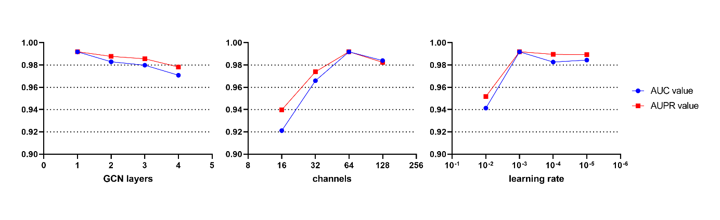

**Supplementary Fig. 1** Impact of parameters on model GutMDA. The figure sequentially shows the effects of the number of graph convolution layers, the number of channels, and the learning rate on the AUC and AUPR value of GutMDA.